# **LUMSÅS Rug, low pile, grey/multi-color**

**Product details $750**

Durable, stain resistant and easy to care for since the rug is made of synthetic fibers.

**Materials & care**

* **Pile:**100% polypropylene
* **Backing:**100 % Synthetic rubber

Cleaning: Use a mild detergent, brush with a soft brush and rinse thoroughly with water. Let the rug dry completely before use Wash by hand, max 40°C.Do not bleach. Do not tumble dry. Do not iron. Do not dry clean . Vacuum and rotate the rug regularly. Professional carpet cleaning when needed.

## Product size

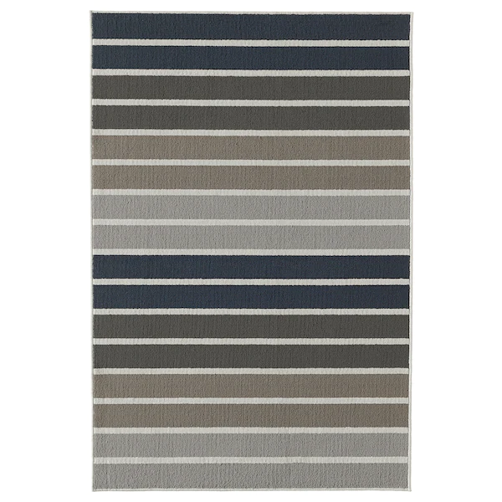**Length:**

180 cm (5 ' 11 ")

**Width:**

120 cm (3 ' 11 ")

**Thickness:**

8 mm (¼ ")

**Area:**

2.16 m² (23.25 sq. feet)

**Surface density:**

980 g/m² (3.21 oz/sq. ft)

**Pile coverage:**

360 g/m² (1.18 oz/sq. ft)